
1. chef: somebody who prepares the food
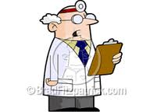
2. doctor: some body who helps sick people

3. policeman: somebody who catches thieves
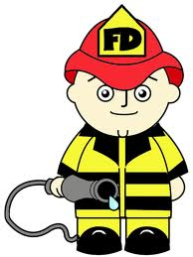
4. fireman: somebody who fights fire
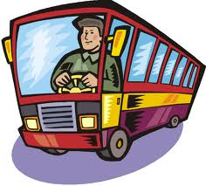
5. driver: somebody who drives a vehicle

6. nurse: somebody who helps doctors

7. f farmer: somebody who grows food

8. postman: somebody who delivers letters

9. seller: somebody who sells goods


